**Project Description:**

According to [World Health Organization](https://www.who.int/news-room/fact-sheets/detail/epilepsy#:~:text=Rates%20of%20disease&text=Globally%2C%20an%20estimated%205%20million,as%20139%20per%20100%20000.) (WHO), around 50 million people with epilepsy live on the earth. This count make epilepsy the most common neurological disorder globally. Around 80% of the patient live in those countries who are low or middle income wise. The general proportion of active cases (continuingly facing seizure attacks or need treatment on urgent bases) are 4 to 10 on every 1000. Around 70% of the people could be cured from this disorder if they are properly treated. It is estimated that new 5 million people are diagnosed with epilepsy on yearly basis. And for high income countries, 49 per 100,000 people got positive of epilepsy each year. And for the country level, [Pakistan](https://nationalepilepsycentre.org.pk/about-epilepsy/) have 1% of its total population which is about 2.2 million patients of epilepsy. According to Research of [National Epilepsy Center](https://nationalepilepsycentre.org.pk), following are some disasters facts about Pakistan and epilepsy.

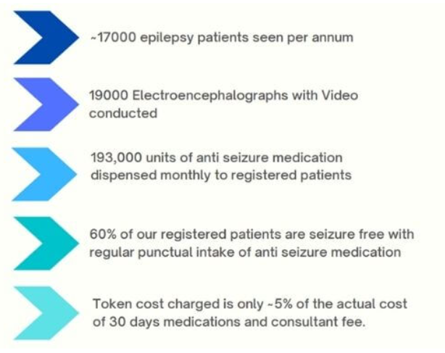

According to research of [National Library of Medicine](https://pubmed.ncbi.nlm.nih.gov/14999166/), epilepsy have quite severe consequences include lifespan shortening, excessive bodily injury, neuropsychological and psychiatric impairment and social disability. These consequences separate the population of epilepsy form the rest of the world.

As the technology advances, life expectancy increases with time. According to research of [BioMed Central](https://bmcgeriatr.biomedcentral.com/articles/10.1186/s12877-020-01524-9#:~:text=Overall%2C%20life%20expectancy%20at%20age,and%204.75%20years%20for%20men.)

These disaster facts motivate the researchers and developers towards a cost effective and reliable solution for the epileptic patients that might improve their life